НАЦІОНАЛЬНИЙ ТЕХНІЧНИЙ УНІВЕРСИТЕТ УКРАЇНИ

«КИЇВСЬКИЙ ПОЛІТЕХНІЧНИЙ ІНСТИТУТ»

ФАКУЛЬТЕТ ІНФОРМАТИКИ І ОБЧИСЛЮВАЛЬНОЇ ТЕХНІКИ

КАФЕДРА ОБЧИСЛЮВАЛЬНОЇ ТЕХНІКИ

**Лабораторна робота №6**

з дисципліни **«**Архітектура комп’ютерів 2**»**

Виконала:

студентка 3 курсу

групи ІВ-82

Чуясова Тетяна

Перевірив:

Нікольський С. С.

Київ 2020 р.

**Лістинг програми:**

**hello.c**

/*

* Copyright (c) 2017, GlobalLogic Ukraine LLC

* All rights reserved.

*

* Redistribution and use in source and binary forms, with or without

* modification, are permitted provided that the following conditions are met:

* 1. Redistributions of source code must retain the above copyright

* notice, this list of conditions and the following disclaimer.

* 2. Redistributions in binary form must reproduce the above copyright

* notice, this list of conditions and the following disclaimer in the

* documentation and/or other materials provided with the distribution.

* 3. All advertising materials mentioning features or use of this software

* must display the following acknowledgement:

* This product includes software developed by the GlobalLogic.

* 4. Neither the name of the GlobalLogic nor the

* names of its contributors may be used to endorse or promote products

* derived from this software without specific prior written permission.

*

* THIS SOFTWARE IS PROVIDED BY GLOBALLOGIC UKRAINE LLC `AS IS` AND ANY

* EXPRESS OR IMPLIED WARRANTIES, INCLUDING, BUT NOT LIMITED TO, THE IMPLIED

* WARRANTIES OF MERCHANTABILITY AND FITNESS FOR A PARTICULAR PURPOSE ARE

* DISCLAIMED. IN NO EVENT SHALL GLOBALLOGIC UKRAINE LLC BE LIABLE FOR ANY

* DIRECT, INDIRECT, INCIDENTAL, SPECIAL, EXEMPLARY, OR CONSEQUENTIAL DAMAGES

* (INCLUDING, BUT NOT LIMITED TO, PROCUREMENT OF SUBSTITUTE GOODS OR SERVICES;

* LOSS OF USE, DATA, OR PROFITS; OR BUSINESS INTERRUPTION) HOWEVER CAUSED AND

* ON ANY THEORY OF LIABILITY, WHETHER IN CONTRACT, STRICT LIABILITY, OR TORT

* (INCLUDING NEGLIGENCE OR OTHERWISE) ARISING IN ANY WAY OUT OF THE USE OF THIS

* SOFTWARE, EVEN IF ADVISED OF THE POSSIBILITY OF SUCH DAMAGE.

*/

#include <linux/init.h>

#include <linux/module.h>

#include <linux/moduleparam.h>

#include <linux/printk.h>

#include <linux/types.h>

#include <linux/ktime.h>

#include <linux/slab.h>

struct head_list {

struct head_list *next;

ktime_t start_time;

};

MODULE_AUTHOR("Chuiasova Tetiana IV-82");

MODULE_DESCRIPTION("Hello world (Linux module for lab6)");

MODULE_LICENSE("Dual BSD/GPL");

static struct head_list *head;

static uint repeat = 1;

module_param(repeat, uint, 0444);

MODULE_PARM_DESC(repeat, "repeat amount");

static int __init hello_init(void)

{

uint i = 0;

struct head_list *this_var, *next_var;

if (!repeat) {

pr_info("Repetition parameter = 0");

pr_info("");

return 0;

} if (repeat >= 5 && repeat <= 10) {

pr_warn("Repetition parameter is between 5 and 10");

} else { if (repeat > 10) {

pr_err("Repetition parameter > 10");

pr_info("");

return -EINVAL; }

}

head = kmalloc(sizeof(struct head_list *), GFP_KERNEL);

this_var = head;

for (i = 0; i < repeat; i++) {

this_var->next = kmalloc(sizeof(struct head_list), GFP_KERNEL);

this_var->start_time = ktime_get();

pr_info("Hello, world!\n");

next_var = this_var;

this_var = this_var->next;

}

pr_info("Repeat: %d\n", repeat);

kfree(next_var->next);

next_var->next = NULL;

return 0;

}

static void __exit hello_exit(void)

{

struct head_list *tmp_var;

while (head != NULL && repeat != 0) {

tmp_var = head;

pr_info("Time of printing: %lld", tmp_var->start_time);

head = tmp_var->next;

kfree(tmp_var);

}

pr_info("");

}

module_init(hello_init);

module_exit(hello_exit);

**MakeFile**

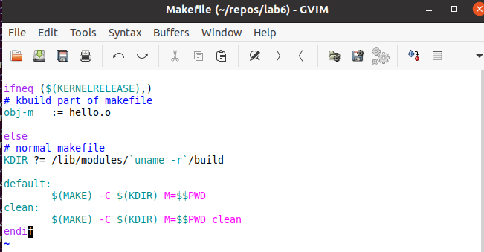

**Посилання на репозиторій:**

https://github.com/txt2021/Lab6_AK

**Результати виконання роботи:**

Приклад №1

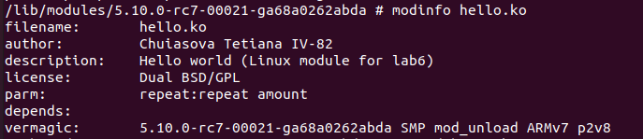

Приклад №2

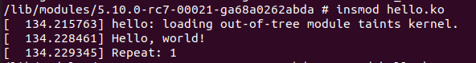



Приклад №3





Приклад №4

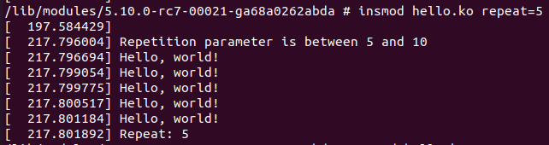

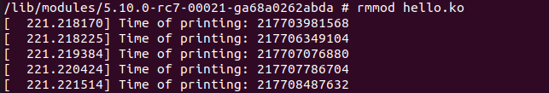

Приклад №5

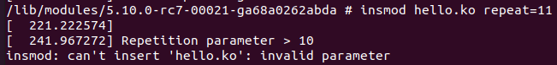

Приклад №6

